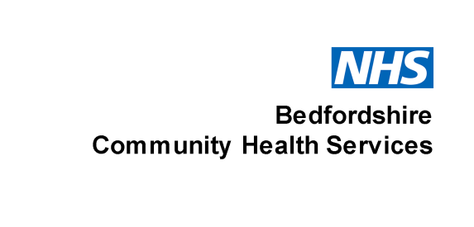
Brushing chart
Week beginning ____________________
Monday |  | Right |  |  | Central | Left
morning | upper
morning | lower
evening | upper
evening | lower
Tuesday |  |  | Right |  | Central |  | Left
morning | upper
morning | lower
evening | upper
evening | lower
Wednesday |  |  | Right |  | Central | Left
morning | upper
morning | lower
evening | upper
evening | lower
Thursday |  |  | Right |  | Central | Left
morning | upper
morning | lower
evening | upper
evening | lower
Friday |  |  | Right |  | Central | Left
morning | upper
morning | lower
evening | upper
evening | lower
Saturday |  |  | Right |  | Central | Left
morning | upper
morning | lower
evening | upper
evening | lower
Sunday |  |  | Right |  | Central | Left
morning | upper
morning | lower
evening | upper
evening | lower
East of England Community Health and Care NHS Trust: providing services across Bedfordshire, Cambridgeshire, Luton, Milton Keynes, Norfolk, Peterborough and Suffolk

Oral Health Improvement Team, Flitwick Health Centre, Highlands, Flitwick, Bedfordshire, MK45 1DZ, Tel: 01525 631223
Bedfordshire adult and children's community health services are provided in partnership
by East London NHS Foundation Trust (ELFT) and Cambridgeshire Community Services (CCS) NHS Trust.

