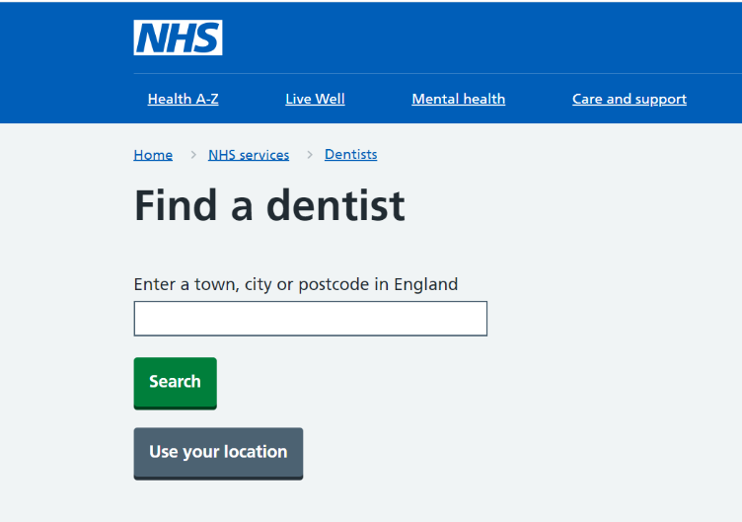

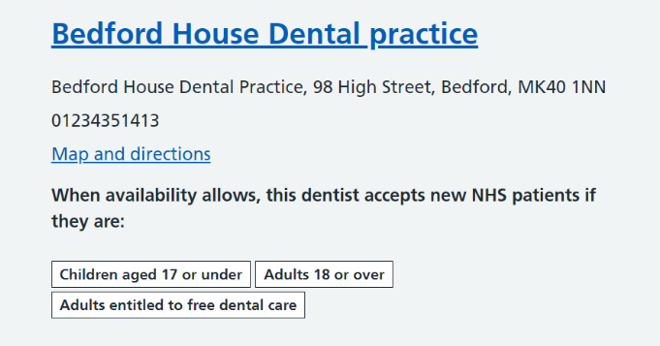

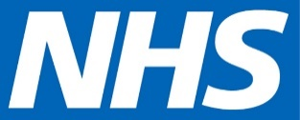
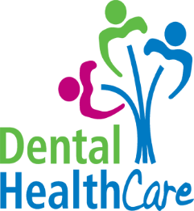
East of England Community Health and Care NHS Trust: providing services across Bedfordshire, Cambridgeshire, Luton, Milton Keynes, Norfolk, Peterborough and Suffolk

Visit www.nhs.uk
- Listings show if the dental practice is accepting new patients.
- Some may not have any information so will need to be called.
For urgent dental care or out of hours care 111 can help you online at 111.nhs.uk or call 111
Do you need help finding an NHS dentist?

